- Create one VPC in N. Virginia region.
1. Task Title**
Create a VPC in the N. Virginia (us-east-1) Region
2. Objective**
To create a custom Virtual Private Cloud (VPC) in the N. Virginia region that will serve as an isolated network environment for deploying AWS resources securely.
3. Prerequisites**
* AWS account with VPC permissions (`ec2:CreateVpc`, `ec2:Describe*`, etc.)
* Login access to AWS Management Console
* Region selected as **N. Virginia (us-east-1)**
* CIDR block planned (e.g., `10.0.0.0/20`)
4. Step-by-Step Implementation**
### **Step 1: Select the Correct Region**
1. Login to **AWS Console**
2. In the top-right corner, choose **N. Virginia (us-east-1)**
### **Step 2: Create the VPC**
1. Navigate to **VPC Console**
2. Click **Your VPCs** → **Create VPC**
3. Choose **VPC Only** (or **VPC and More** if you want subnets, IGW, etc.)
4. Enter:
* **Name tag:** `My-VPC`
* **IPv4 CIDR block:** `10.0.0.0/16`
* Leave IPv6 optional
* Tenancy: **Default**
- Click **Create VPC**
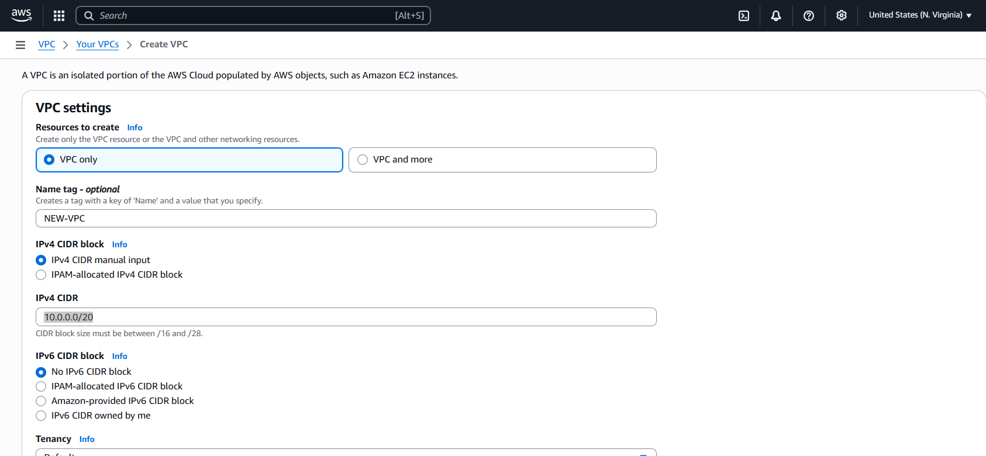
5. Validation Steps**
1. In VPC Console → **Your VPCs**, confirm the new VPC exists
2. Check:
* CIDR block: `10.0.0.0/16`
* Region: **us-east-1**
* Status: **Available**
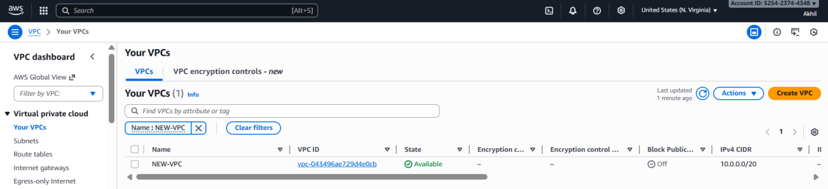
6. Conclusion**
The VPC was successfully created in the N. Virginia region (us-east-1).
- Create two subnets: one public subnet and one private subnet.
1. Task Title**
Create Public and Private Subnets in a VPC
2. Objective**
To create one public and one private subnet within an existing VPC
3. Prerequisites**
* An existing VPC
* AWS account with IAM permissions to manage VPC and subnets
* Region selected where the VPC exists
* Understanding of CIDR notation
4. Step-by-Step Implementation**
### **Step 1: Plan CIDR Allocation**
* VPC CIDR: **10.0.0.0/20** (provides 4096 IPs)
* Allocate two /24 subnets:
* Public Subnet: **10.0.1.0/24**
* Private Subnet: **10.0.2.0/24**
### **Step 2: Create Public Subnet**
1. Open **VPC Dashboard** → *Subnets* → *Create Subnet*.
2. Choose your VPC (10.0.0.0/20).
3. Enter:
* Name: **Public-Subnet**
* AZ: Select any availability zone
* CIDR: **10.0.1.0/24**
4. Click **Create Subnet**.
5. Edit subnet settings → Enable **Auto-assign public IPv4**.
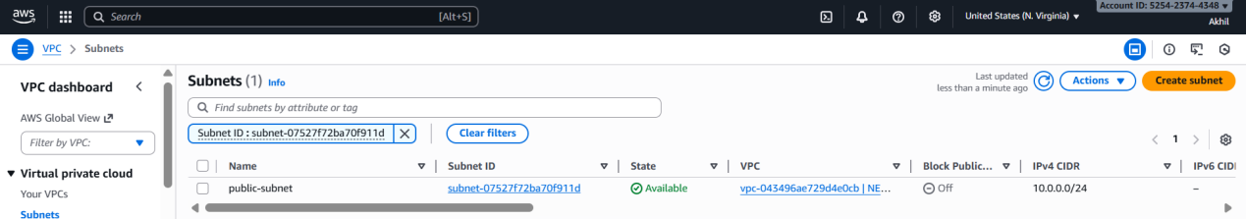
### **Step 3: Create Private Subnet**
1. Go to *Create Subnet* again.
2. Choose the same VPC.
3. Enter:
* Name: **Private-Subnet**
* AZ: Same or different as public (your choice)
* CIDR: **10.0.2.0/24**
4. Click **Create Subnet**.
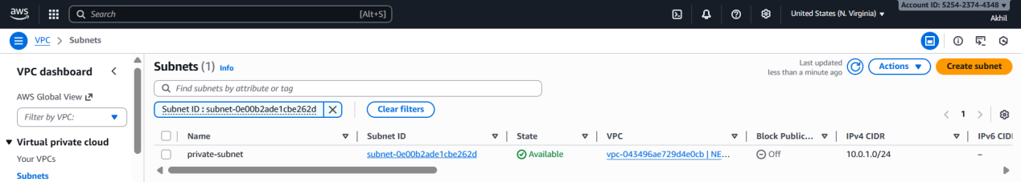
5. Validation
6. Conclusion**
The VPC was successfully divided into one public and one private subnet.
- Attach an IGW to the VPC.
1. Task Title**
Attach an Internet Gateway (IGW) to a VPC
2. Objective**
To create and attach an Internet Gateway to the existing VPC so that resources in the public subnet can access the internet.
3. Prerequisites**
* An existing VPC with CIDR **10.0.0.0/20**
* IAM permissions to create and manage Internet Gateways
* AWS Management Console access
* At least one subnet designated as **Public Subnet**
4. Step-by-Step Implementation**
### **Step 1: Create an Internet Gateway**

1. Open **VPC Dashboard**.
2. Select **Internet Gateways** → *Create internet gateway*.
3. Enter a name, e.g., **My-VPC-IGW**.
4. Click **Create internet gateway**.
### **Step 2: Attach the IGW to the VPC**
1. Select the newly created IGW
2. Click **Actions** → **Attach to VPC**.
3. Choose your VPC: **10.0.0.0/20**.
4. Click **Attach internet gateway**.
5. Validation Steps*
* Navigate to **Internet Gateways** and verify status shows **Attached** to your VPC.
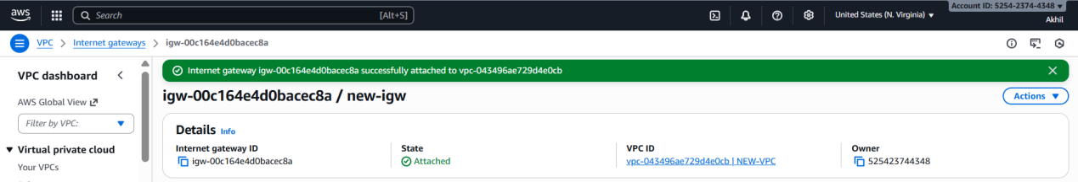
6. Conclusion**
The Internet Gateway was successfully created and attached to the VPC, enabling public subnet resources to access the internet.
- Create one public route table (RT) and one private route table.
1. Task Title**
Create Public and Private Route Tables in a VPC
2. Objective**
To create separate route tables for public and private subnets, ensuring correct routing for internet-facing and internal resources.
3. Prerequisites**
* Existing VPC with CIDR **10.0.0.0/20**
* Public and private subnets already created
* An attached **Internet Gateway (IGW)**
* Optional: NAT Gateway if private subnet needs outbound internet
* IAM permissions to manage route tables
4. Step-by-Step Implementation**
### **Step 1: Create the Public Route Table**
1. Go to **VPC Dashboard** → *Route Tables*.
2. Click **Create route table**.
3. Name: **Public-RT**
4. Select your VPC (10.0.0.0/20).
5. Click **Create route table**.
### **Step 2: Add Internet Route to Public RT**
1. Open **Public-RT**.
2. Go to **Routes** → *Edit routes*.
3. Add route:
* Destination: `0.0.0.0/0`
* Target: Your **Internet Gateway (IGW)**
4. Save changes.
### **Step 3: Associate Public Subnet with Public RT**
1. Open **Public-RT**.
2. Go to **Subnet associations** → *Edit associations*.
3. Select your **Public Subnet (10.0.1.0/24)**.
4. Save.
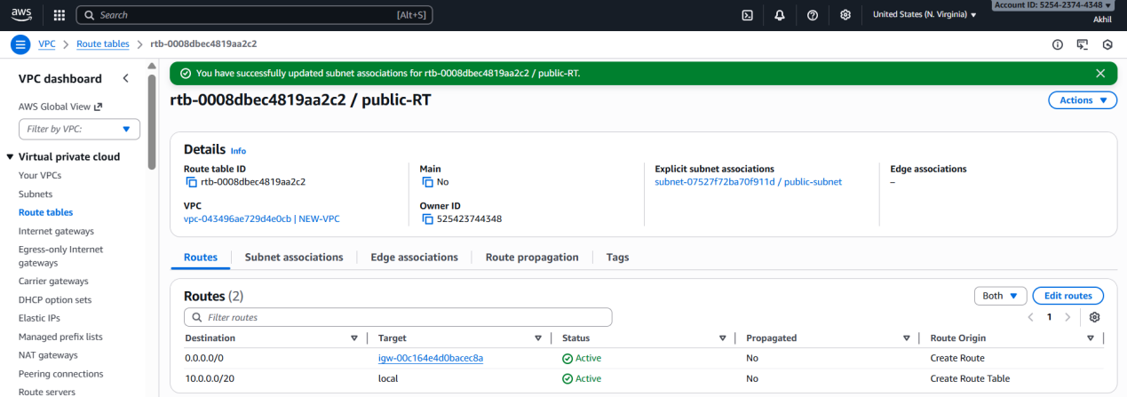

### **Step 4: Create the Private Route Table**
1. Return to **Route Tables** → *Create route table*.
2. Name: **Private-RT**
3. Select your VPC.
4. Click **Create route table**.

### **Step 5: Associate Private Subnet with Private RT**
1. Open **Private-RT**.
2. Go to **Subnet associations** → *Edit associations*.
3. Select **Private Subnet (10.0.2.0/24)**.
4. Save.
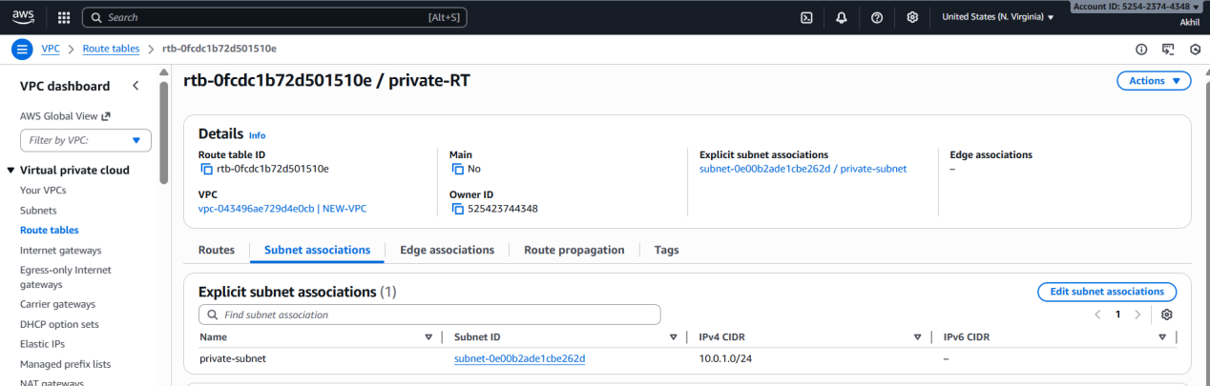

5. Validation Steps**

* Verify **Public-RT** has a route to the IGW.
* Verify **Public Subnet** appears under its associations.
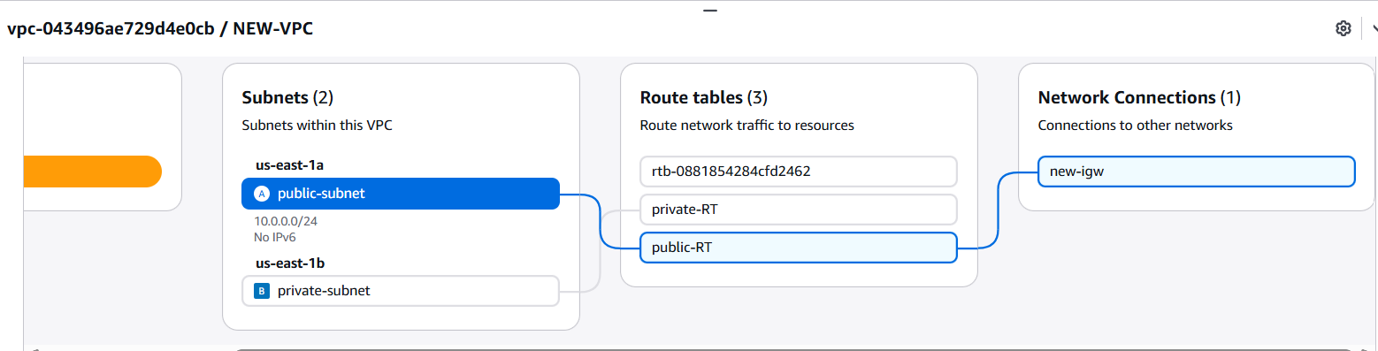
* Verify **Private-RT** does **not** have IGW as a target.
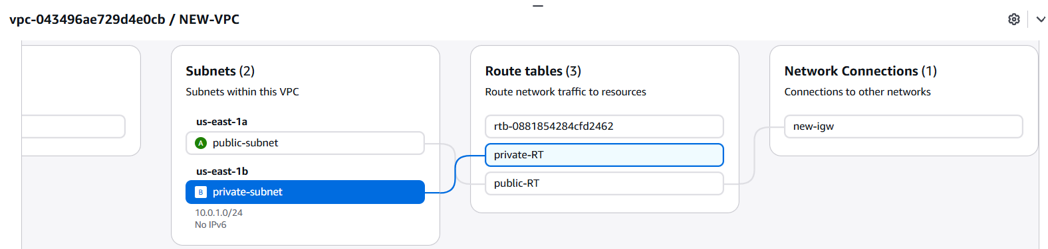
6. Conclusion**
The public and private route tables were successfully created and associated with their respective subnets, ensuring proper network routing and segmentation within the VPC.
- Deploy a NAT gateway in the public subnet and attach the NAT gateway to the private subnet.
1. Task Title**
Deploy NAT Gateway and Configure Private Subnet Routing
2. Objective**
To create a NAT Gateway in the public subnet and configure the private route table so private subnet instances can access the internet securely.
3. Prerequisites**
* VPC with CIDR **10.0.0.0/20**
* Public Subnet (**10.0.1.0/24**)
* Private Subnet (**10.0.2.0/24**)
* Internet Gateway (IGW) attached to the VPC
* Public Route Table and Private Route Table created
* **Elastic IP (EIP)** availability
* IAM permissions to manage NAT Gateways and Route Tables
4. Step-by-Step Implementation**
### **Step 1: Allocate an Elastic IP**
1. Open **VPC Dashboard**.
2. Navigate to **Elastic IPs** → *Allocate Elastic IP address*.
3. Click **Allocate** and note the newly created EIP.
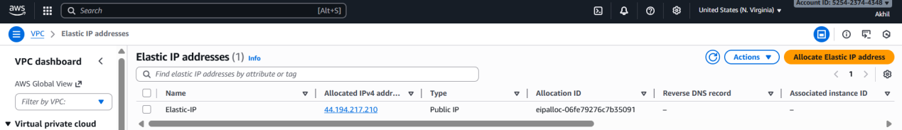
### **Step 2: Create a NAT Gateway in the Public Subnet**
1. Go to **NAT Gateways** → *Create NAT gateway*.
2. Select options:
* **Subnet:** Choose **Public Subnet (10.0.1.0/24)**
* **Elastic IP:** Select the EIP allocated above
3. Click **Create NAT gateway**.
4. Wait until its status becomes **Available**.
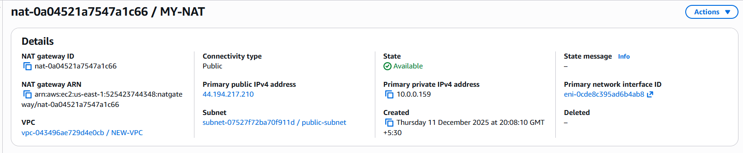
### **Step 3: Update Private Route Table to Use NAT Gateway**
1. Go to **Route Tables** → Open **Private-RT**.
2. Select the **Routes** tab → *Edit routes*.
3. Add a new route:
* Destination: `0.0.0.0/0`
* Target: **NAT Gateway** created above
- Save changes.
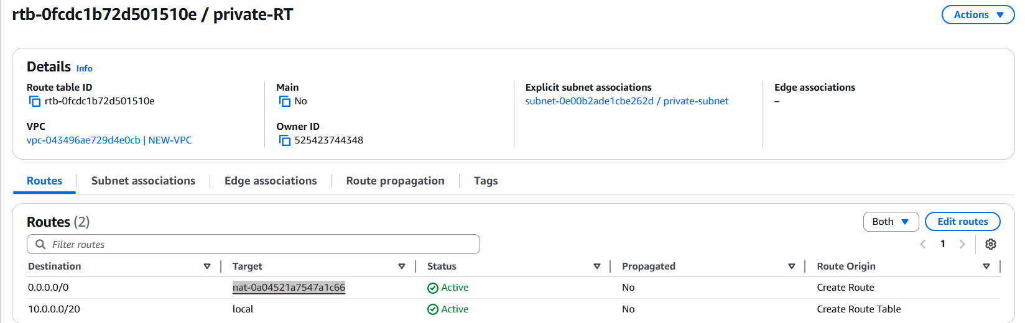

- Validation Steps**
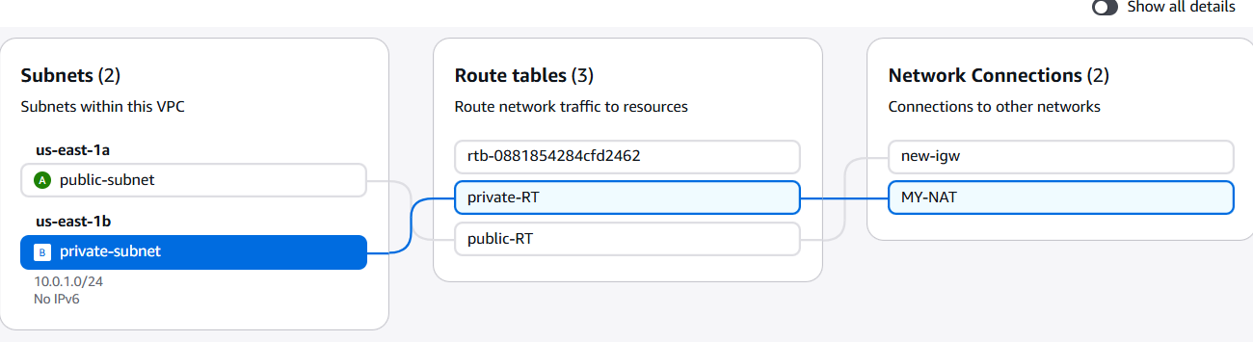
6. Conclusion**
The NAT Gateway was successfully deployed in the public subnet and attached via routing to the private subnet, enabling secure outbound internet access for private resources.

- Create two instances, one in the public subnet and one in the private subnet.
1. Task Title**
Launch Public and Private EC2 Instances
2. Objective**
To deploy one EC2 instance in the public subnet and another in the private subnet for testing connectivity and verifying subnet routing.
3. Prerequisites**

* VPC with CIDR **10.0.0.0/20**
* Public Subnet (**10.0.1.0/24**)
* Private Subnet (**10.0.2.0/24**)
* IGW attached and NAT Gateway configured
* Public and private route tables created and associated
* Key pair for SSH access
* IAM permissions to launch EC2 instances
* Security groups created (or ability to create them)
4. Step-by-Step Implementation**
### **Step 1: Launch Instance in Public Subnet**
1. Go to **EC2 → Launch instance**.
2. Name: **Public-EC2**
3. AMI: Amazon Linux 2 (or any of your choice)
4. Instance type: t2.micro (or equivalent)
5. Key pair: Select existing or create new
6. Network settings:
* VPC: Your VPC (10.0.0.0/20)
* Subnet: **Public Subnet (10.0.1.0/24)**
* Auto-assign public IP: **Enable**
* Security group: Select as per requirement default , Inbound rules:
* Allow **SSH (22)** from your IP
* Optional: Allow HTTP/HTTPS if hosting a web server

7. Launch the instance.
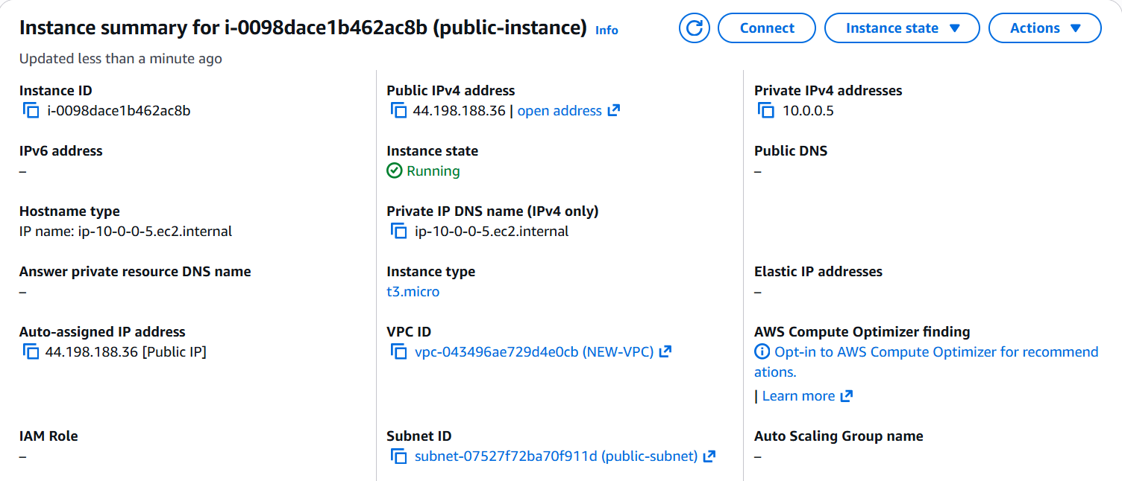
### **Step 2: Launch Instance in Private Subnet**
1. Go to **EC2 → Launch instance**.
2. Name: **Private-EC2**
3. AMI: Amazon Linux 2 (or any of your choice)
4. Instance type: t2.micro
5. Key pair: Select the same key pair
6. Network settings:
* VPC: Same VPC
* Subnet: **Private Subnet (10.0.2.0/24)**
* Auto-assign public IP: **Disable**
* Security group: Select as per requirement default, Inbound rules:
* Allow **SSH (22)** from your IP
* Optional: Allow HTTP/HTTPS if hosting a web server
7. Launch the instance.
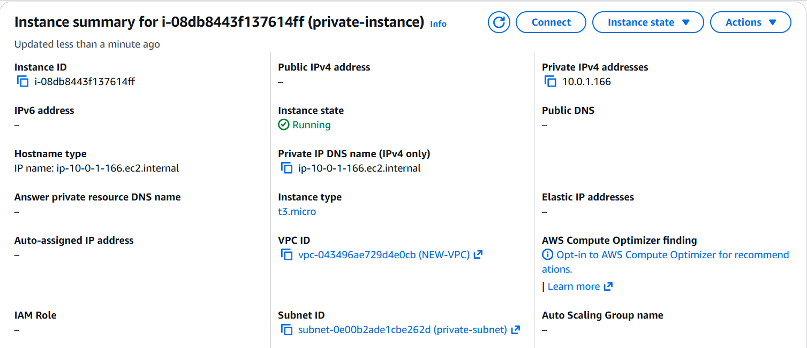
5. Validation Steps**
### **Public Instance Validation**
* Connect using SSH:
`ssh -i <your-key.pem> ec2-user@<public-ip>`
* Run:
`curl google.com` → Should work (internet access).
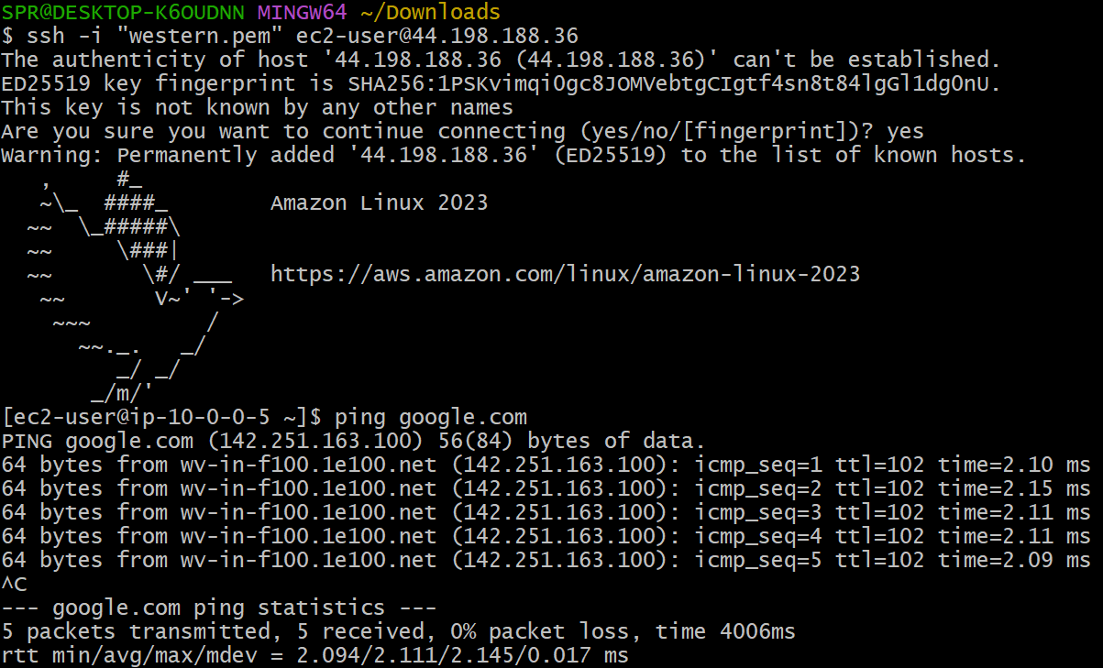
### **Private Instance Validation**
* SSH into the private instance through the public instance (bastion):
1. Connect to Public EC2 first.
2. Then from Public-EC2:
`ssh -i <your-key.pem> ec2-user@<private-ip>`
* Test NAT access:
`curl google.com` → Should work (internet via NAT).
* Test isolation:
* Private EC2 should NOT be reachable from the internet.
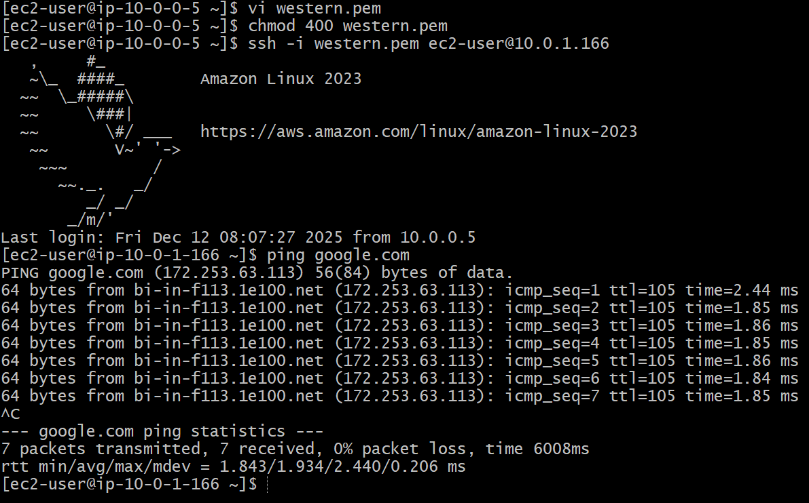
6. Conclusion**
A public EC2 instance and a private EC2 instance were successfully created within their respective subnets, confirming proper VPC segmentation and routing functionality.
- Deploy Apache server on both EC2 instances with a sample index.html file.
1. Task Title**
Deploy Apache Web Server on Public and Private EC2 Instances
2. Objective**
To install and configure Apache HTTP Server on both EC2 instances and serve a sample `index.html` webpage.

3. Prerequisites**
* One EC2 instance running in **Public Subnet**
* One EC2 instance running in **Private Subnet**
* SSH access to Public EC2
* Ability to SSH into Private EC2 through the Public instance (bastion)
* Amazon Linux 2 or similar Linux-based AMI
* Security group rules allowing:
* **HTTP (80)** access for public instance
* Internal access only for private instance (as required)
4. Step-by-Step Implementation**
### **Step 1: SSH into Public EC2 Instance**
ssh -i your-key.pem ec2-user@<public-ec2-public-ip>
### **Step 2: Install Apache on Public EC2**
sudo yum update -y
sudo yum install httpd -y
### **Step 3: Start & Enable Apache**
sudo systemctl start httpd
sudo systemctl enable httpd
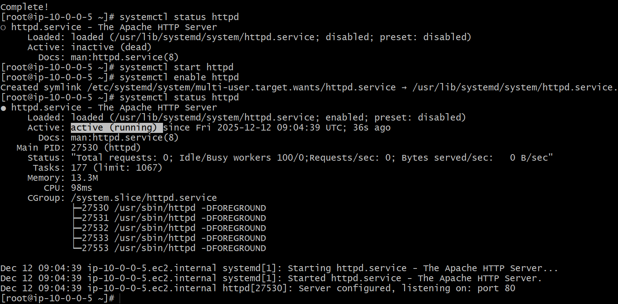
### **Step 4: Create Sample index.html on Public EC2**
echo "<h1>Welcome to Public EC2 Web Server</h1>" | sudo tee /var/www/html/index.html
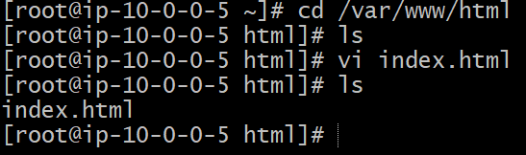
### **Step 5: SSH into Private EC2 via Public EC2**
First SSH into public EC2, then:
ssh -i your-key.pem ec2-user@<private-ec2-private-ip>
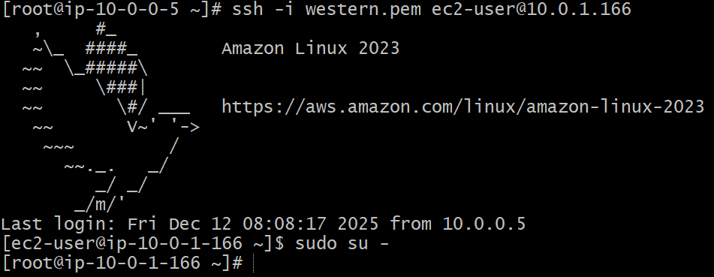
### **Step 6: Install Apache on Private EC2**
sudo yum update -y
sudo yum install httpd -y
### **Step 7: Start & Enable Apache**
sudo systemctl start httpd
sudo systemctl enable httpd
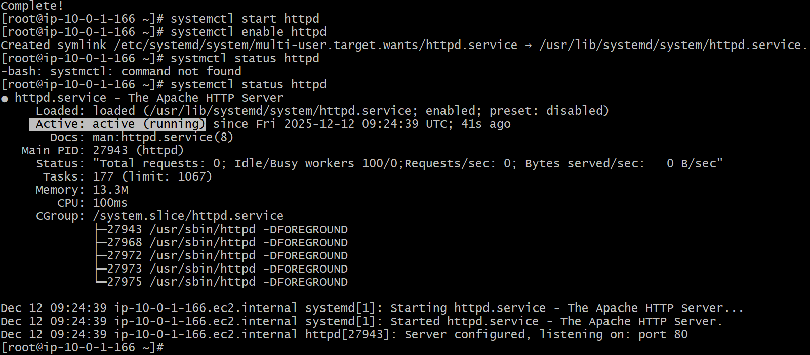
### **Step 8: Create Sample index.html on Private EC2**
echo "<h1>Welcome to Private EC2 Web Server</h1>" | sudo tee /var/www/html/index.html
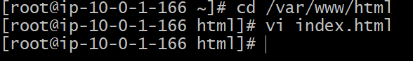
5. Validation Steps**
### **Public EC2 Validation**
* Open a browser:
`http://<public-ec2-public-ip>`
* You should see: **“Welcome to Public EC2 Web Server”**
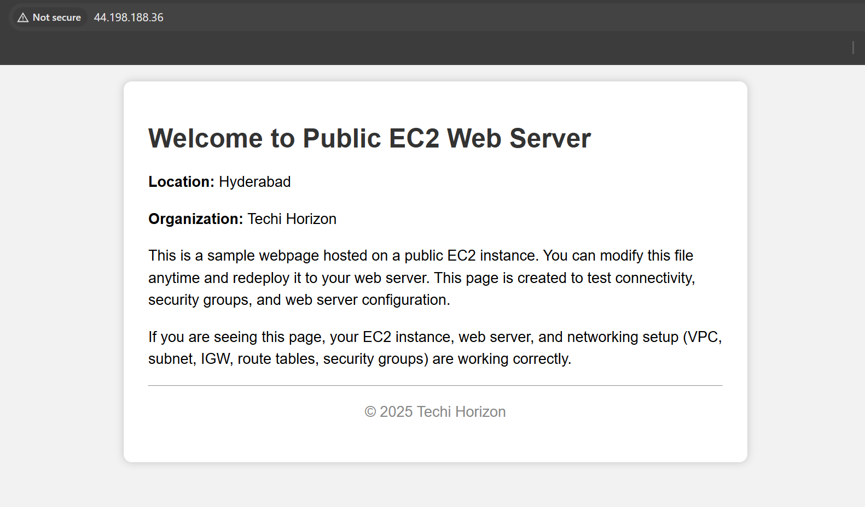
### **Private EC2 Validation**
* From Public EC2 instance, run:
curl http://<private-ec2-private-ip>
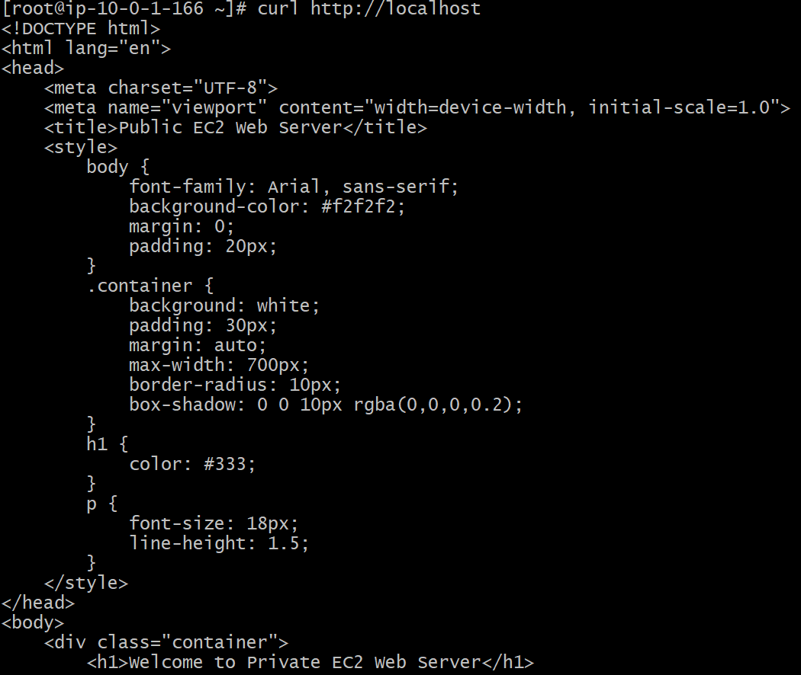
6. Conclusion**
Apache web servers were successfully deployed on both the public and private EC2 instances with sample HTML pages, confirming proper connectivity and server configuration.

- Create one application load balancer and attach it to both EC2 instances.
1. Task Title**
Create an Application Load Balancer and Register Public & Private EC2 Instances

2. Objective**
To deploy an Application Load Balancer (ALB) and attach both EC2 instances (public and private) so traffic is distributed between them.
3. Prerequisites**
* VPC with public & private subnets
* Two EC2 instances:
* **Public-EC2**
* **Private-EC2**
* Apache installed and running on both instances
* Security groups configured:
* SG allowing inbound HTTP (80) from anywhere
* Instance SGs allowing inbound HTTP
* IAM permissions to create load balancers and target groups
4. Step-by-Step Implementation**
### **Step 1: Create a Target Group**
1. Go to **EC2 Console → Load Balancing → Target Groups**.
2. Click **Create target group**.
3. Settings:
* Target type: **Instance**
* Name: **App-TG**
* Protocol: **HTTP**
* Port: **80**
* VPC: Select your VPC
4. Click **Next**.
5. Select both EC2 instances (**Public-EC2** and **Private-EC2**)
6. Set their ports to **80**, then click **Register targets**.
7. Click **Create target group**.
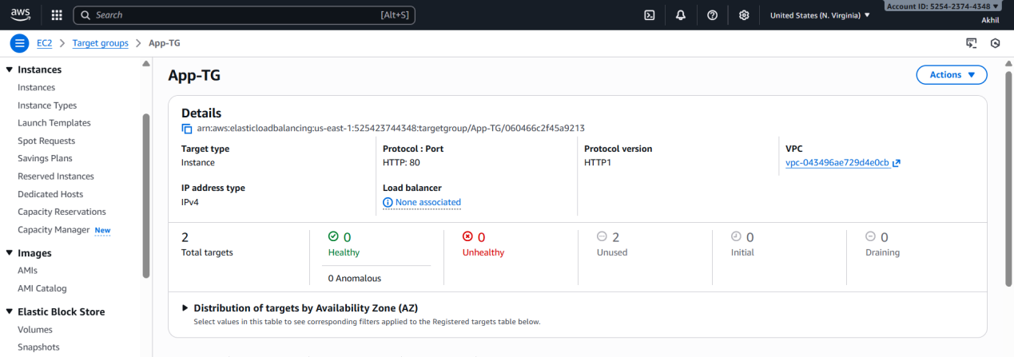
### **Step 2: Create ALB (Application Load Balancer)**
1. Go to **EC2 → Load Balancers → Create Load Balancer**.
2. Select **Application Load Balancer**.
3. Name: **App-ALB**
4. Scheme: **Internet-facing**
5. IP type: **IPv4**
6. **Network mappings:**
* Select your VPC
* Choose **at least two subnets**:
* Public Subnet (10.0.1.0/24)
* Private Subnet (10.0.2.0/24)
7. **Security Groups:**
* Select an SG that allows:
* HTTP (80) from 0.0.0.0/0
8. **Listeners:**
* Protocol: HTTP
* Port: 80
* Forward to: **App-TG(target group)**
9. Click **Create load balancer**.
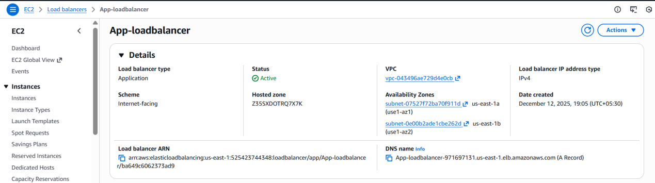
### **Step 3: Verify Health Checks**
1. Go to **Target Groups → App-TG → Health checks**.
2. Ensure health check path = `/`
3. Confirm both instances become **healthy**.
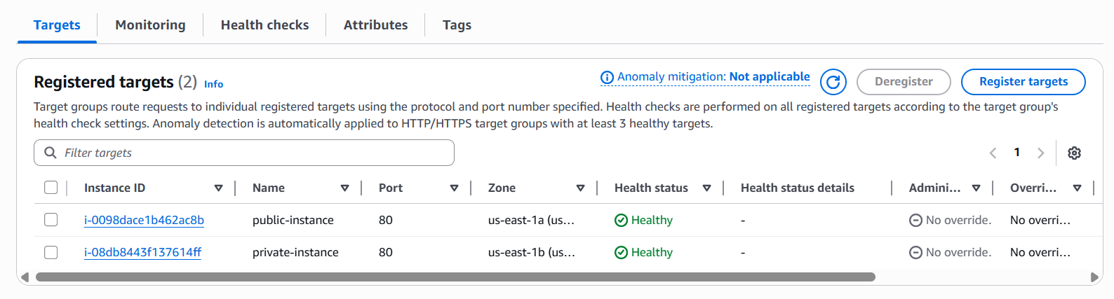
5. Validation Steps**
### **ALB Validation**
* Get the ALB DNS name from EC2 → Load Balancers → Description
* Open:
http://<ALB-DNS-Name>
* You should see:
* “Welcome to Public EC2 Web Server” (sometimes)
* “Welcome to Private EC2 Web Server” (depending on load balancing)
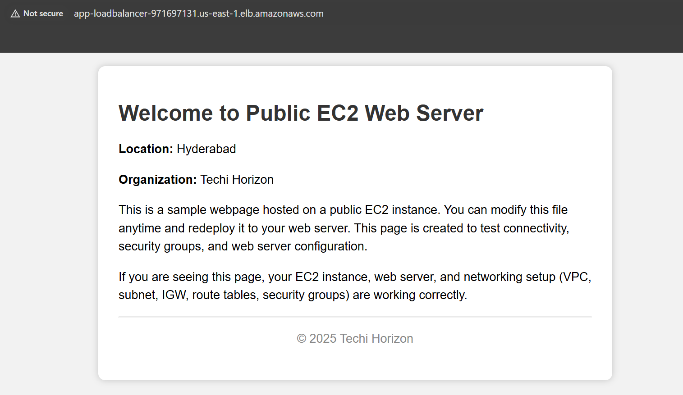
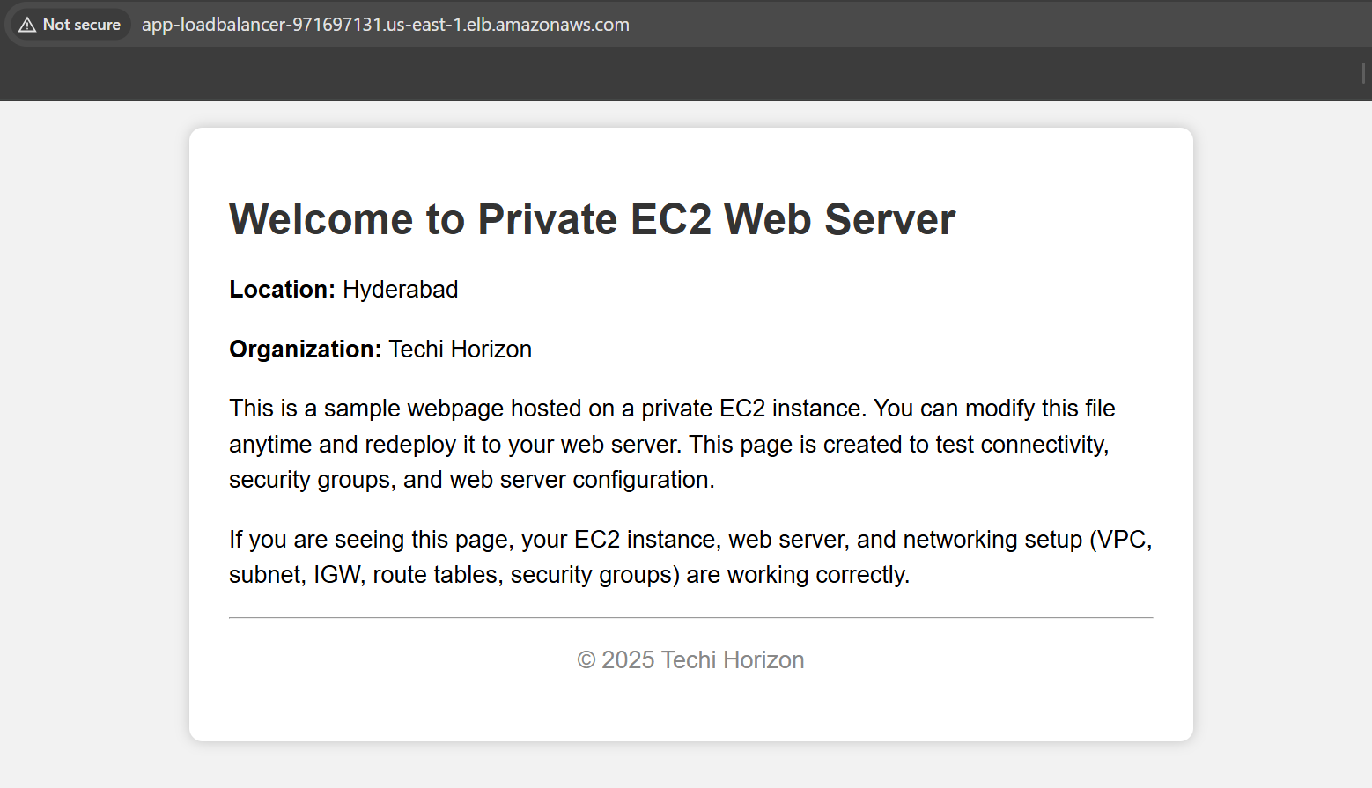
6. Conclusion**
The Application Load Balancer was successfully created and configured with both the public and private EC2 instances, ensuring incoming traffic is distributed efficiently across both servers.
- Store application load balancer logs in S3.

1. Task Title**

Enable Access Logging for Application Load Balancer and Store Logs in S3

2. Objective**

To configure the Application Load Balancer (ALB) to store access logs in an S3 bucket for monitoring and auditing traffic.

3. Prerequisites**

* An existing **Application Load Balancer (ALB)**
* An **S3 bucket** created for storing logs
* Correct S3 bucket permissions allowing ALB to write logs
* IAM permissions to modify ALB attributes
* Bucket policy configured for ALB logging

4. Step-by-Step Implementation**

### **Step 1: Create an S3 Bucket**

1. Go to **S3 Console** → Click **Create bucket**.
2. Name the bucket: **alb-access-logs-<yourname>**
3. Choose the same region as the ALB.
4. Disable *Block all public access* (optional; recommended to keep ON).
5. Create the bucket.

### **Step 2: Add Bucket Policy for ALB Logging**

Go to the S3 bucket → **Permissions → Bucket Policy** and paste the policy below:

> **Important:** Replace `YOUR_BUCKET_NAME` and `YOUR_REGION`.

```json
{
"Version": "2012-10-17",
"Statement": [
{
"Effect": "Allow",
"Principal": {
"AWS": "arn:aws:iam::127311923021:root"
},
"Action": "s3:PutObject",
"Resource": "arn:aws:s3:::alb-access-logs-854662/AWSLogs/525423744348/*"
}
]
}

```

Click **Save**.
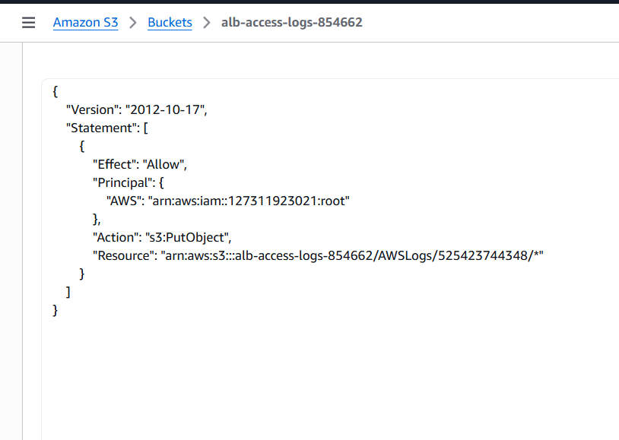

### **Step 3: Enable Logging in the ALB Settings**

1. Go to **EC2 Console → Load Balancers**.
2. Select your ALB (**App-ALB**).
3. Navigate to the **Attributes** tab.
4. Under **Access Logs**, click **Edit**.
5. Enable **Access logs**.
6. Select:

* **S3 bucket name:** your bucket
* **S3 prefix:** (optional) for folder structure, e.g., `alb-logs/`
7. Save changes.

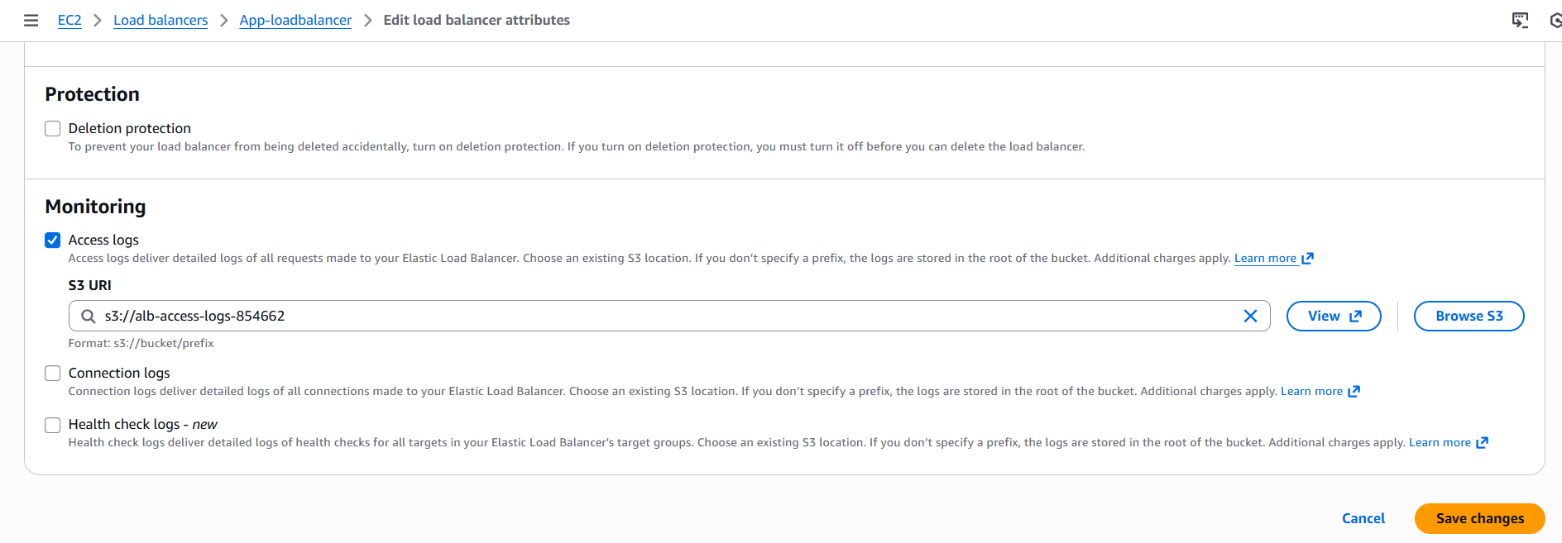
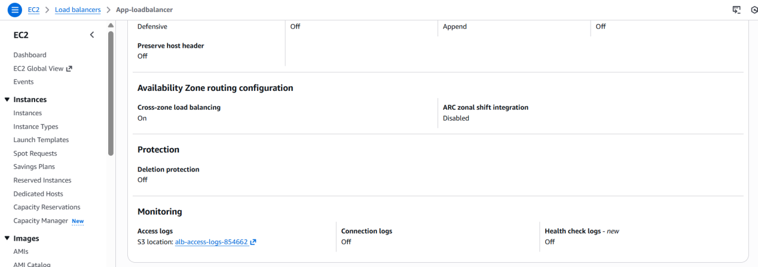

5. Validation Steps**

### **Step 1: Generate Traffic**
Open the ALB URL:
http://<ALB-DNS-Name>

Refresh multiple times.

### **Step 2: Check S3 Bucket**

1. Go to your S3 bucket.
2. Navigate to:

alb-logs/AWSLogs/<AWS-Account-ID>/elasticloadbalancing/<region>/

3. Confirm you see `.log.gz` files being created (may take 5–10 minutes).

### **Step 3: Download and View Log File**

Download a log file, unzip it, and open with any text viewer.
You should see entries representing each request made through the ALB.

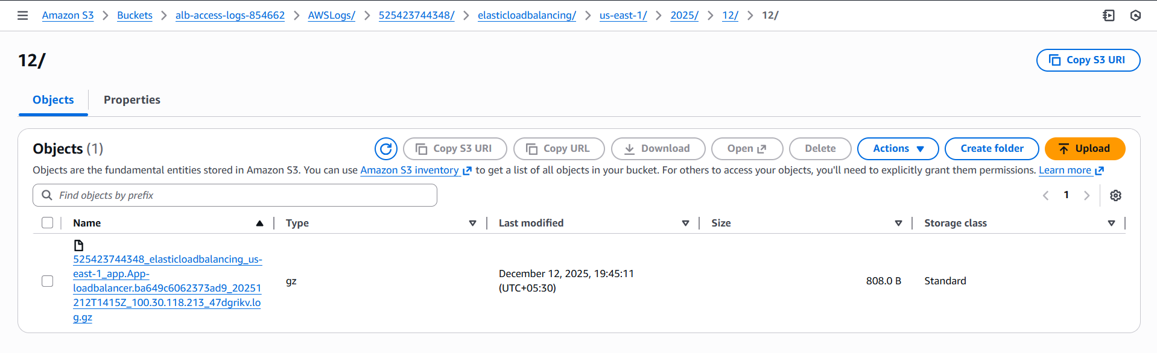
6. Conclusion**

ALB access logging was successfully enabled, and all logs are now being stored securely in the configured S3 bucket for auditing, monitoring, and analysis.

- Store the VPC flow logs in a CloudWatch log group.

1. Task Title**

Enable VPC Flow Logs and Store Them in CloudWatch Logs

2. Objective**

To capture VPC network traffic and store the flow logs in a CloudWatch Log Group for monitoring and troubleshooting.

3. Prerequisites**

* Existing VPC (CIDR: **10.0.0.0/20**)
* IAM permissions to create:

* VPC Flow Logs
* IAM role for publishing logs to CloudWatch
* CloudWatch log groups
* CloudWatch service enabled in the Region
* VPC should not have any existing flow log conflicts

4. Step-by-Step Implementation**

### **Step 1: Create a CloudWatch Log Group**

1. Go to **CloudWatch Console**.
2. Navigate to **Logs → Log groups**.
3. Click **Create log group**.
4. Name it:

```
/vpc-flow-logs/<your-vpc-name>
```
5. Choose retention period (e.g., 30 days).
6. Click **Create**.

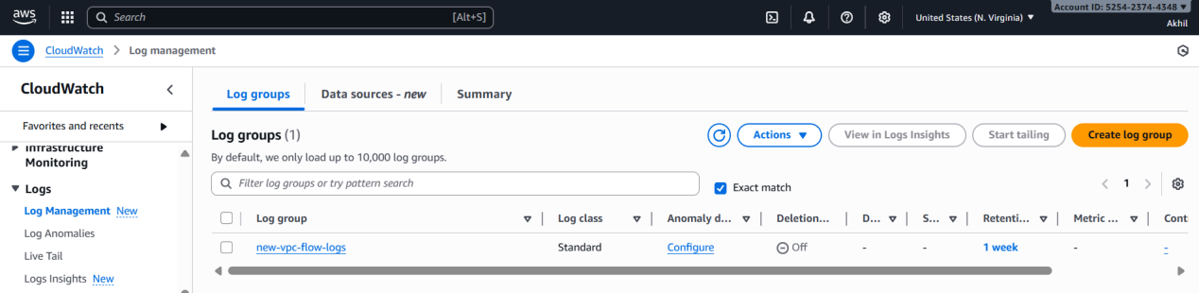

### **Step 2: Create IAM Role for Flow Logs**

This role allows VPC Flow Logs to publish logs to CloudWatch.

1. Go to **IAM Console → Roles → Create role**.
2. Select **AWS service** → **EC2** (for flow logs delivery).
3. Attach policy **CloudWatchLogsFullAccess** or use recommended AWS-managed policy:

* `AWSFlowLogs`
4. Name the role:

```
VPCFlowLogsToCloudWatchRole
```
5. Create the role.

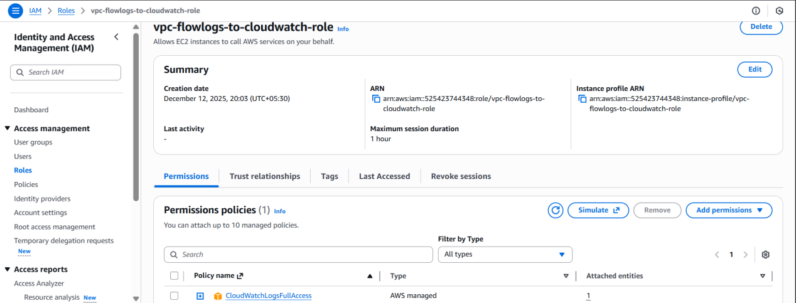

### **Step 3: Enable VPC Flow Logs**

1. Go to **VPC Console → Your VPCs**.
2. Select your VPC (10.0.0.0/20).
3. Click **Flow Logs** tab → **Create flow log**.

Fill the form:

* **Filter:** All (ALL traffic)
* **Destination:** CloudWatch Logs
* **Log group:** Select `/vpc-flow-logs/<your-vpc-name>`
* **IAM Role:** `VPCFlowLogsToCloudWatchRole`
* **Format:** Default format (recommended)
* **Max aggregation interval:** 10 minutes (default)

- Click **Create flow log**.
* The status should show **Active** within a minute.
* If status shows **Failed**, check IAM role permissions.

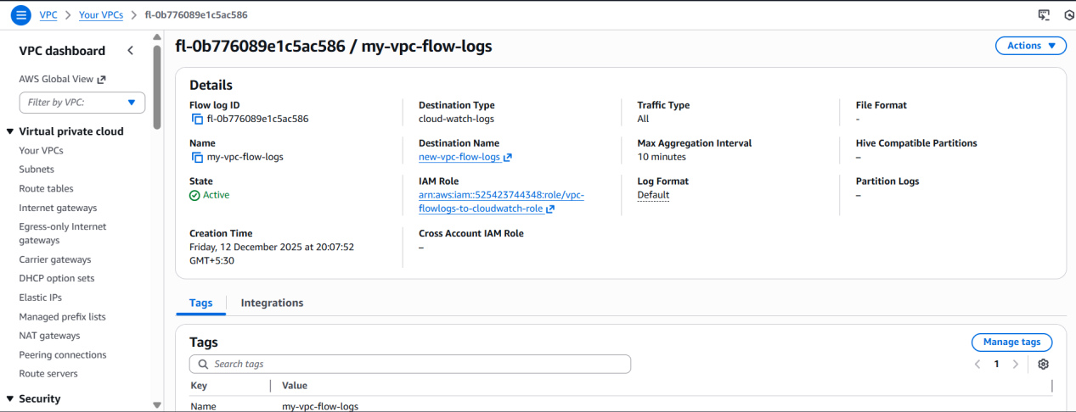

5. Validation Steps**

### **1. Generate Network Traffic**

* Use your EC2 instances to make pings, curls, or SSH connections.

### **2. Check CloudWatch Logs**

1. Go to **CloudWatch Console → Log groups**.
2. Open the log group:

```
/vpc-flow-logs/<your-vpc-name>
```
3. You should see log streams named by network interface IDs (eni-xxxx).
4. Open a log stream and verify entries like:

ACCEPT
REJECT
TCP/UDP traffic logs

### **3. Confirm Continuous Logging**

* Wait a few minutes and refresh to confirm new entries are being added.

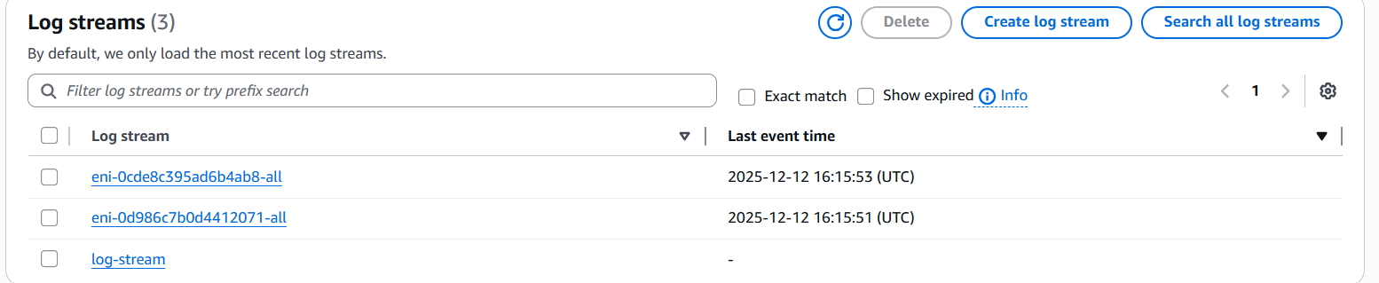
6. Conclusion**

VPC flow logs were successfully enabled and stored in a CloudWatch log group, allowing continuous monitoring and analysis of network traffic within the VPC.

- Create monitoring dashboards to monitor CPU utilization and to monitor the Apache service.

1. Task Title**
Create CloudWatch Dashboards for CPU Utilization and Apache Service Monitoring
2. Objective**
To build two CloudWatch dashboards—one to monitor EC2 CPU utilization and another to monitor Apache HTTP service health and activity.
3. Prerequisites**
* both EC2 instances (Public & Private) running
* CloudWatch Agent installed on the instances (for Apache monitoring)
* IAM permissions to:
* Create dashboards
* View EC2 metrics
* Publish/log custom metrics
* Apache service already installed and running on both servers
4. Step-by-Step Implementation**
# **PART A — Create a CPU Utilization Monitoring Dashboard**
### **Step 1: Open CloudWatch Dashboards**
1. Go to **CloudWatch Console**
2. Click **Dashboards** → **Create dashboard**
3. Name the dashboard:
EC2-Monitoring-Dashboard
## **Step 2: Add CPU Utilization Widget**
1. Choose **Line Widget**
2. Click **Next**
3. Under **Metrics → EC2 → Per-Instance Metrics**
4. Select:
* `CPUUtilization` for **Public EC2**
* `CPUUtilization` for **Private EC2**
5. Click **Create Widget**
You now have a real-time CPU monitoring graph for both instances.
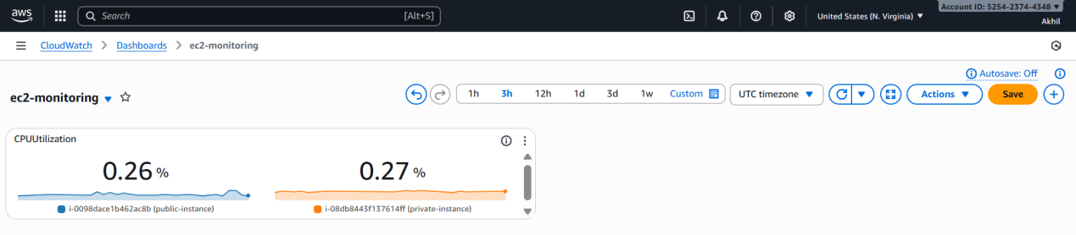

# **PART B — Monitor Apache Service Using CloudWatch Agent & Logs**
Monitoring Apache requires custom metrics because AWS does not natively track Apache service status.
# **Step 3: Install CloudWatch Agent (Both EC2 Instances)**
Run on **each EC2 instance**:
sudo yum install amazon-cloudwatch-agent -y
### **Step 4: Create CloudWatch Agent Config for Apache Monitoring**
Create the config file:
sudo vi /opt/aws/amazon-cloudwatch-agent/bin/config.json
Paste:
```json
{
"metrics": {
"append_dimensions": {
"InstanceId": "${aws:InstanceId}"
},
"metrics_collected": {
"procstat": [
{
"pattern": "httpd",
"measurement": [
"cpu_usage",
"memory_rss"
]
}
]
}
}
}

This monitors Apache's **CPU usage** and **memory usage** via `httpd` process.
### **Step 5: Start the CloudWatch Agent**
sudo /opt/aws/amazon-cloudwatch-agent/bin/amazon-cloudwatch-agent-ctl \
-a fetch-config -m ec2 -c file:/opt/aws/amazon-cloudwatch-agent/bin/config.json -s

Verify agent is running:
sudo systemctl status amazon-cloudwatch-agent
### **Step 6: Create an Apache Monitoring Dashboard**

1. Go to **CloudWatch → Dashboards**
2. Create a new dashboard:
Apache-Monitoring-Dashboard
3. Add a **Line Widget**
4. Select metrics:
* **CWAgent → procstat → cpu_usage**
* **CWAgent → procstat → memory_rss**
For both:
* Public EC2
* Private EC2
5. Create the widget.
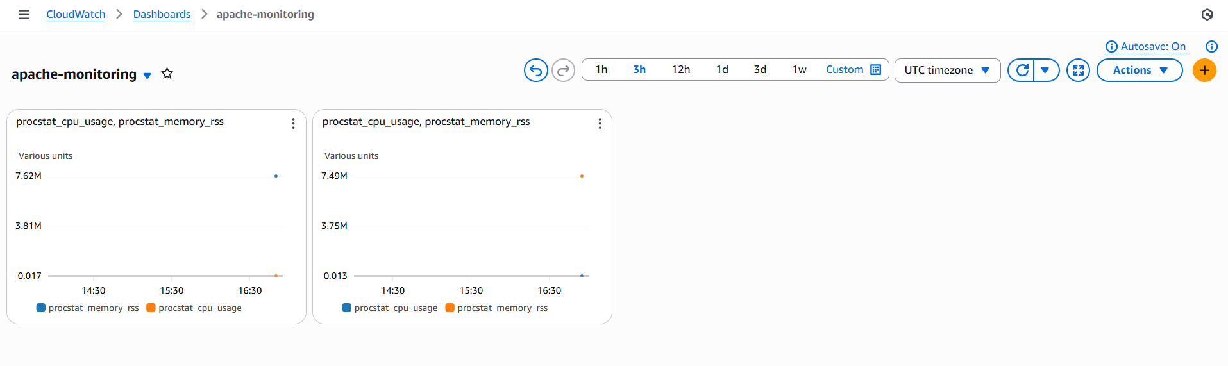
5. Validation Steps**
### **CPU Dashboard Validation**
* Stress the CPU on an instance:
yes > /dev/null &
* Watch CloudWatch dashboard update within 1–2 minutes.
### **Apache Monitoring Validation**
1. Restart Apache:
sudo systemctl restart httpd
2. Refresh dashboard:
* `procstat_cpu_usage` should temporarily spike
* `procstat_memory_rss` updates accordingly

3. Kill Apache:
sudo systemctl stop httpd
* CPU/memory metrics drop to 0, indicating downtime.
4. Restart it:
sudo systemctl start httpd
6. Conclusion**
Two CloudWatch dashboards were successfully created—one for CPU monitoring and another for Apache service health. The setup provides real-time visibility into system performance and ensures continuous monitoring of your environment.

- If CPU utilization is more than 70%, then it should trigger auto scaling and launch new instance.

1. Task Title**

Configure Auto Scaling Triggered by High CPU Utilization

2. Objective**

To create an Auto Scaling Group (ASG) that automatically launches a new EC2 instance whenever CPU utilization exceeds **70%** on existing instances.

3. Prerequisites**

* Existing VPC with public/private subnets
* ALB already created (optional but recommended)
* A working EC2 instance with Apache installed (used as launch template base)
* IAM permissions for:

* Auto Scaling
* Launch Templates
* CloudWatch Alarms
* Security groups ready
* Proper routing/NAT for subnets
* Amazon Linux 2 AMI or equivalent

4. Step-by-Step Implementation**

# **PART A — Create a Launch Template**

### **Step 1: Create Launch Template**

1. Go to **EC2 Console → Launch Templates → Create Launch Template**
2. Template name:

```
Apache-ASG-Template
```
3. Choose AMI:

* Amazon Linux 2 (same as your existing EC2)
4. Instance type:

* t2.micro (or your choice)
5. Key pair:

* Select existing
6. Network settings:

* Do **NOT** select a subnet (ASG manages this)
7. User data (for Apache installation):

```bash
#!/bin/bash
yum update -y
yum install httpd -y
systemctl enable httpd
systemctl start httpd
echo "<h1>New Auto-Scaled Instance Running Apache</h1>" > /var/www/html/index.html
```

8. Create the template.

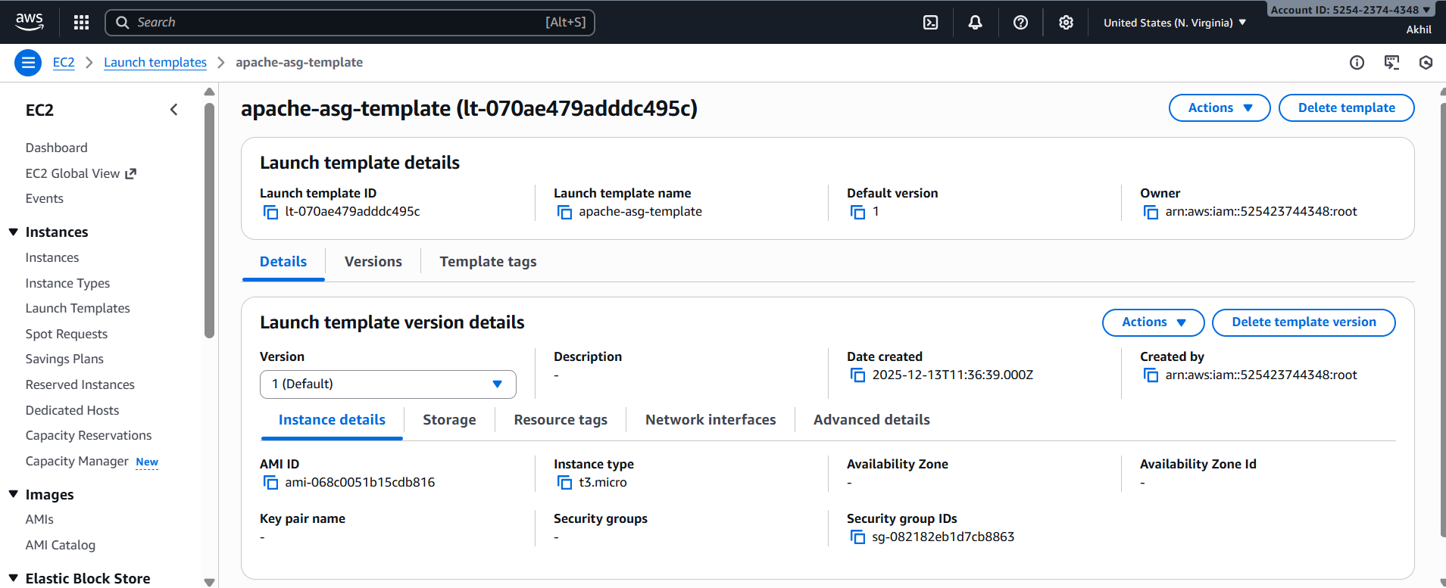

# **PART B — Create the Auto Scaling Group**

### **Step 2: Create ASG**

1. Go to **Auto Scaling Groups → Create ASG**
2. Choose your launch template: **Apache-ASG-Template**
3. Set ASG name:

```
Apache-AutoScaling-Group
```
4. Select your VPC (10.0.0.0/20)
5. Select subnets:

* Public OR Private subnets (based on your design)

> **Recommended:** Use **private subnets** and let ALB forward traffic.

6. Attach to an existing ALB:

* Choose **Application Load Balancer**
* Choose your **App-TG** target group

---

### **Step 3: Define Desired Capacity**

* Desired capacity: **1**
* Minimum capacity: **1**
* Maximum capacity: **3**

Click **Next**.

---

# **PART C — Configure Scaling Policy (CPU > 70%)**

### **Step 4: Add Scaling Policy**

Under “Dynamic Scaling Policy”:

1. Click **Add Policy**
2. Policy type: **Simple Scaling** or **Target Tracking Scaling**

### **Recommended: Target Tracking Policy**

Select:

* Metric type: **Average CPU Utilization**
* Target value: **70%**

This means:

* If CPU > 70% → ASG launches new instance
* Once CPU stabilizes < 70% → instances scale back down

Click **Create scaling policy**.

---

# **PART D — CloudWatch Alarm (Auto-Created)**

### **Step 5: Review CloudWatch Alarm**

ASG automatically creates:

* **High CPU Alarm** → triggers scale-out
* **Low CPU Alarm** → triggers scale-in

No manual configuration required.

5. Validation Steps**

### **1. Stress the CPU on the existing EC2 instance**

SSH into the running instance and run:

```bash
yes > /dev/null &
```

This will push CPU above 90%.

### **2. Watch CloudWatch Alarm Trigger**

Go to:

```
CloudWatch → Alarms → CPUUtilization
```

Status will change to **ALARM**.

### **3. Check ASG Activity**

Go to:

```
Auto Scaling Groups → Apache-AutoScaling-Group → Activity
```

You should see:

* “Launching a new EC2 instance due to high CPU”

### **4. Verify New Instance is Registered with ALB**

Go to:

```
Target Groups → App-TG
```

You should see:

* A new instance becoming **healthy**

### **5. Kill CPU Stress Program**

Run:

```bash
killall yes
```

### **6. Watch Auto Scale-In (Optional)**

If CPU falls low for long, ASG may remove extra instances depending on your scale-in policy.

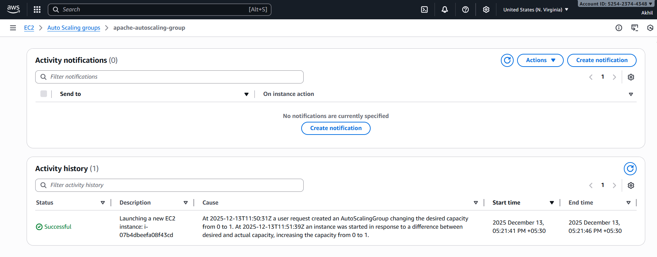

6. Conclusion**

Auto Scaling was successfully configured so that whenever CPU utilization rises above **70%**, a new EC2 instance is automatically launched, ensuring high availability and resilient application performance.

